**CYBER SECURITY**

ASSIGNMENT

**Question 1:**

1. ● Create payload for windows.
2. ● Transfer the payload to the victim's machine.
3. ● Exploit the victim's machine.

Create Game.exe in Kali and tried opening In Victim Machine

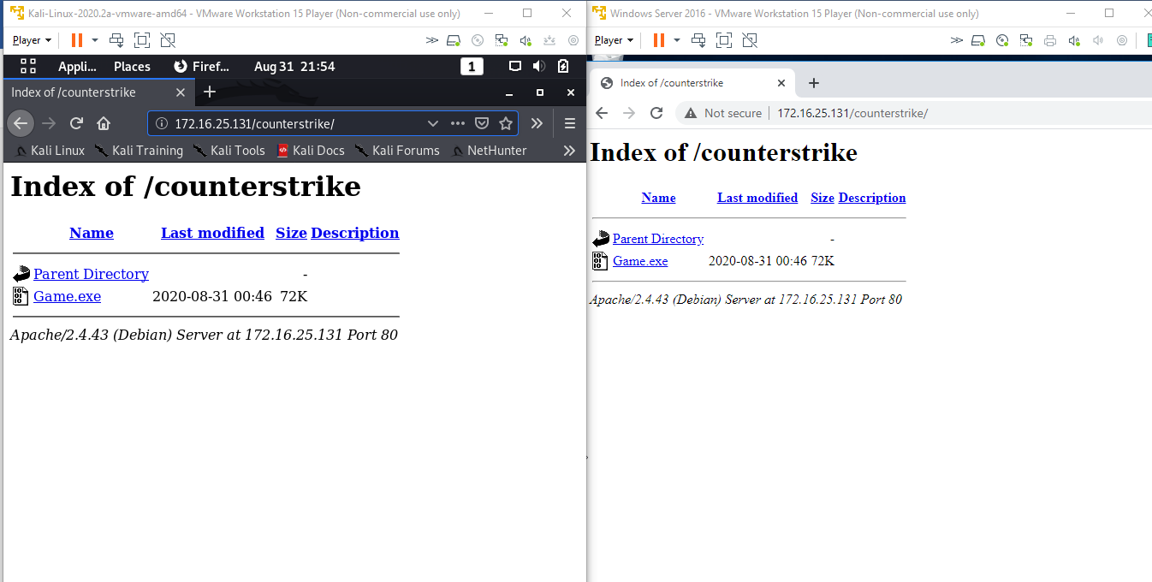

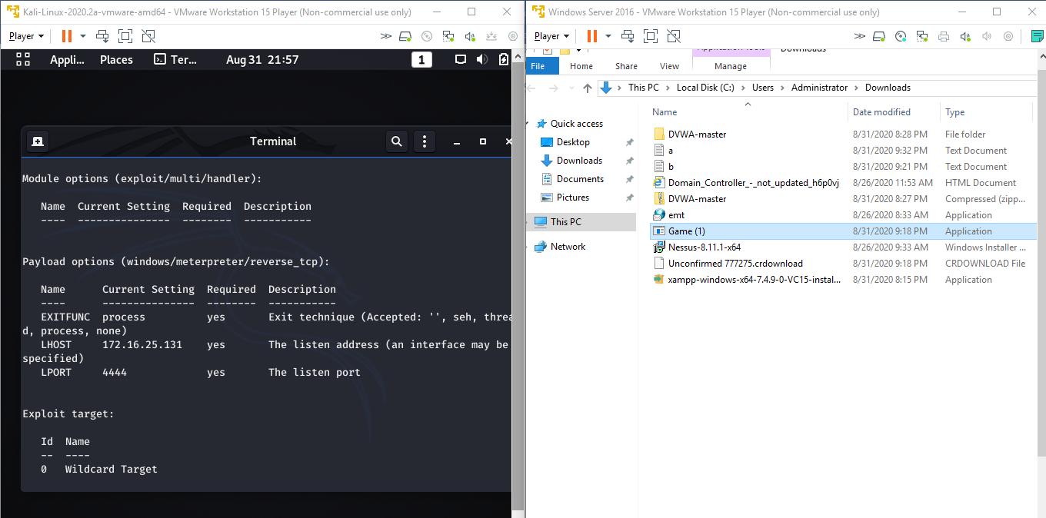

Exploitation Started of the Victim Machine (All details received from the Victim Machine)

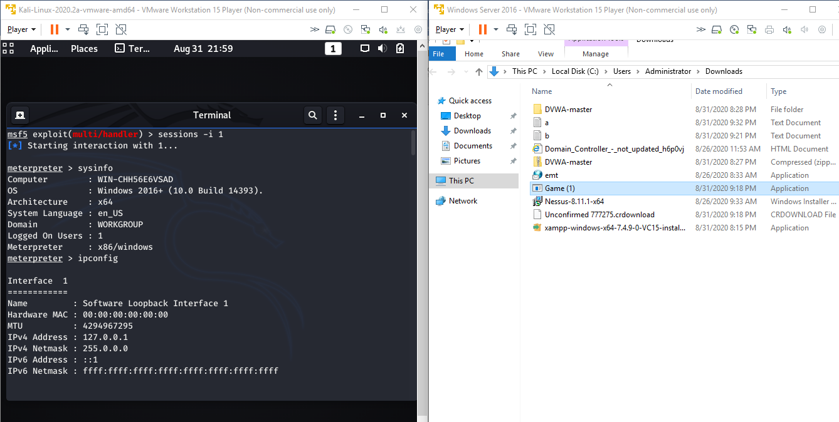

Upload and Download of the a.txt & b.txt in the Victim Machine successfully

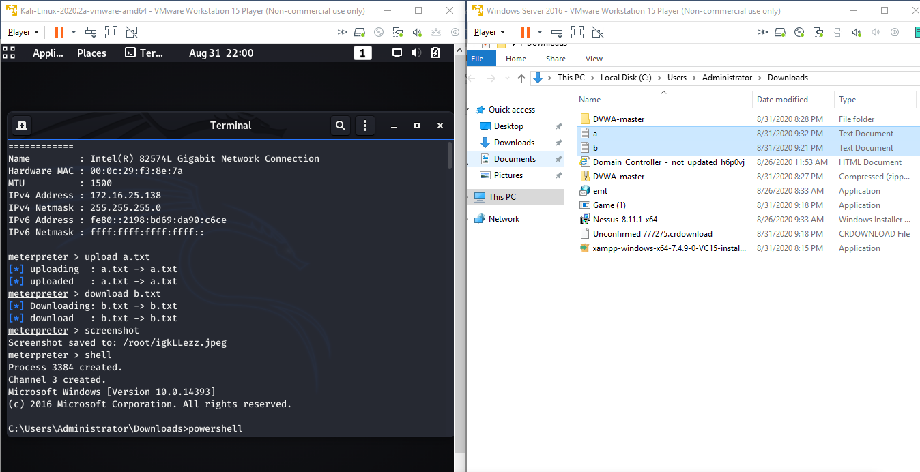

Screenshot taken of the Victim Machine

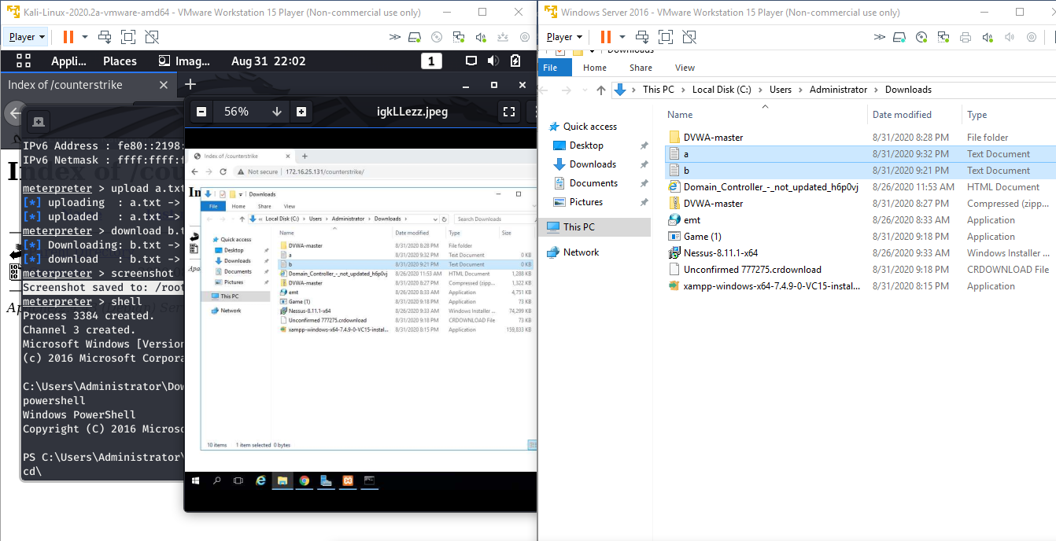

Made the CPU memory a bit high by increasing the load from kali in the Victims Machine

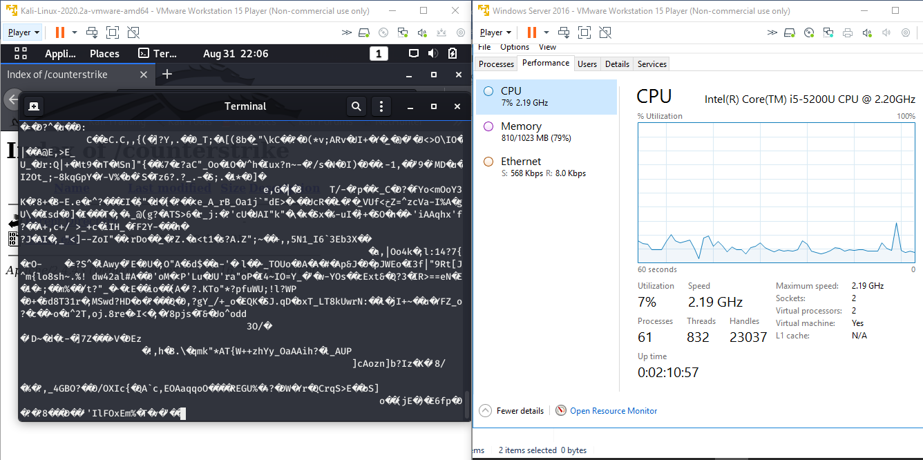

**Question 2**:

1. ● Create an FTP server
2. ● Access FTP server from windows command prompt
3. ● Do an mitm and username and password of FTP transaction using wireshark and dsniff.

Created FTP in Victim and Able to log in in FTP from Pen Tester System

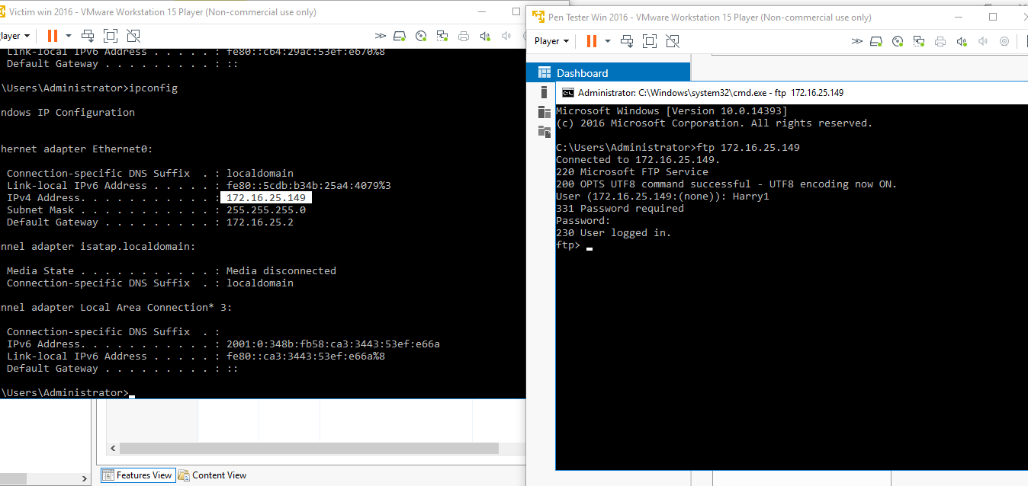

Using dsniff Username & Password of Ftp transaction is displayed below

Username of FTP: - Harry1

Password: - 1234@abcd

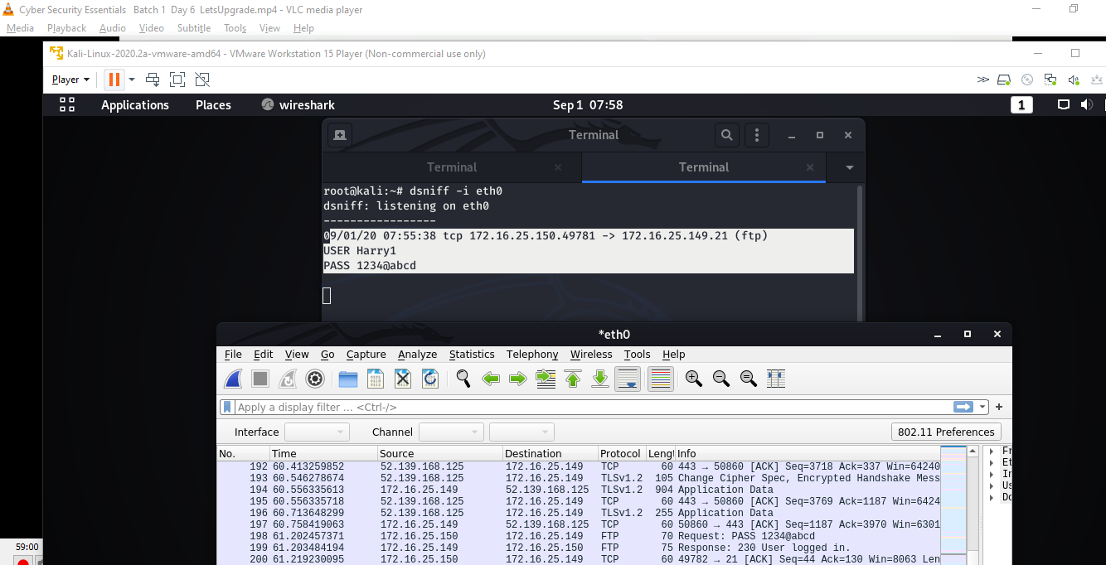

Using Wireshark Username & Password of Ftp transaction is displayed below

Username of FTP: - Harry1

Password: - 1234@abcd

